Contact:
Account Executive-Armando Alva
armandoalva000@gmail.com

Writer-Aracely Aguilera
aracely_2923@yahoo.com

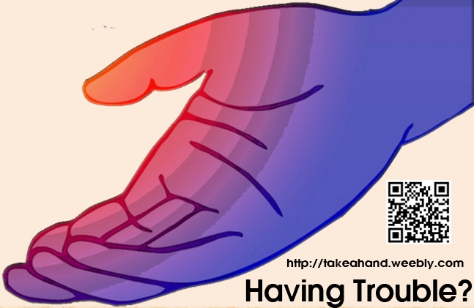

Have a Problem? Take a Hand

Why be afraid to pass along a hand to those in need? High school students create a campaign to get others to overcome their fears to ask or give help.
Los Angeles (March 13, 2013) - A team of high school students from Foshay Learning Center are creating an ad design campaign dealing with teenagers who might be afraid to lend or take a hand when someone needs it.
The target audience is Foshay high school students. The plan is to have these students overcome their fears in lending or taking a hand.
During nutrition or lunch the team will be handing out stickers and businesses cards with the logo and contact information. The event is raffling out names and whoever gets chosen will have to help out another person in need. By doing this they will overcome their fears in lending a hand and will know when to TAKE a HAND.
“All it takes is a hand to make a difference,” said Jocelyn Hernandez, former Foshay high school student.
Why will some people not accept or offer help? The team interviewed three high school students from Foshay asking this question. They believed asking for help or taking a hand shows a sign of weakness. In reality asking for help will strengthen the person.
“Most people don't turn to someone until things are crashing down,” said Enrique Illescas, 12th grade Foshay student.
Asking and receiving help avoids some of those problems high school students face in school. Continuing the cycle of lending/taking a hand while teaching the audience the importance of lending and taking a hand is the goal.
Students in the Foshay Technology Academy are required to design an ad campaign dealing with a common high school problem and coming up with solutions. We are a team organizing these events to help high school students overcome their fears in lending or taking a hand when someone needs it. We will influence people to pass along the hand.
“Get a hand when you need, give a hand when someone needs it,” said Eric Bravo.
For more information visit http://takeahand.weebly.com.

####

